REV-EDITION/DASHBOARD F/UP UPDATES
Allzone started dashboard follow-up effect from 1st of March’2022.
- Effective 2nd of March’22, all databases will need to have the follow-up dashboard worked daily. Please list each database and the number of incomplete follow-up notes that are due each day.

- To get the accurate numbers, start on the follow-up dashboard, choose user AZ, remove the first date completely and the second date is today's date. Refresh the screen by clicking on the red box with blue arrows on the upper right hand of the screen. This will show you the number of follow up notes for each database.

- Effective from [3rd of Aug’22], please run the collection worksheet in Raintree like we used to do, for insurance balances over 30-days since last date billed and then work those accounts.
- Continue to utilize apply action to last open follow up note including follow up due dates. Temporarily you can discontinue working the follow ups from the dashboard.

DASHBOARD FOLLOW-UP CODES:
With immediate effect 1st of June’22, Please see below steps and work the dashboard follow-up by date added wise.
Step1:- Select “Dat” database.
Step2:- Choose the grouping options as "Date added".
Step3:- The second grouping option as "Customer".
Once selected the above options then it will show you the oldest follow-up notes that need to be worked on first and this will help with the aging numbers which have continued to go up.
See sample print screen,
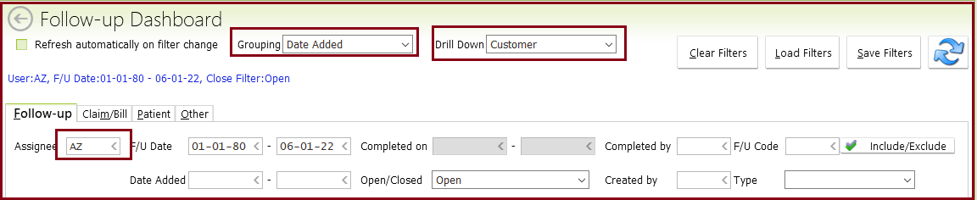
PROGRAMME SETTINGS on REV-EDITION CODES:
Moving forward 24th of May’22, if we getting any questions pertaining to programmed settings (example: where the A0 rejections are being routed, or how B11's are being handled) please only send those to [Kristen Miller]. Please DO NOT to be cc'd to all of the APMB employees in the company.
OAHU DATASET [MEDICARE REJECTIONS]:-
If we receive rejections with missing GP modifier for Medicare claims, please add GP modifier and re-bill as a new claim without the original claim number.
FOLLOW-UP NOTES:
With immediate effect 26th of April’22, please mark as “Complete and Save” for all OLD follow-up notes whenever pasting a new follow-up note. So, it will be reduce from Dashboard follow-up counts.
CO-119 DENIAL FOR MEDI-CAL PATIENTS:
If claim denied as CO-119 Benefit maximum for this time period or occurrence has been reached for Medi-Cal patients. Please check Medi-Cal was paid their fee schedule allowed amount and adjust-off the balance.
ELECTRONIC CLAIM BATCHES:
With Immediate effect 9th of March’22, please work through Dashboard Follow-up claims only, since APMB will STOP to upload Electronic Claim batches in ebridge.
LIST OF PAYERS:
Please DO NOT work for the following payers in Dashboard follow-up sine these payers claims we be taking care at APMB end.
Sl. No | Datasets | Payers
1 | All Psychology datasets | Optum Health
2 | PHS Group | The Paradise Valley
3 | PHS Group | IMS or US Marshalls
4 | Moyer | Sharp Mesa Vista Unfunded
5 | Miller | Alpine
6 | Miller | LAC Department
7 | Sanders | Alvarado Parkway Inst
8 | Nguyen Dat | Alvarado Medical Center
SEND PENDING FOLLOW-UP COUNTS:
Please SEND all pending dashboard follow-up counts [AZ & KAM1] on daily basis to client.
ZERO DOLLAR BILL BARS
Moving forward 24th of May’22, if received any zero dollar bill bars in dashboard follow-up, please ignore it.
VOICE MESSAGE:
For all databases, when we leave a message with an insurance company, please make AZ the assigned user and have a follow-up date. That is 1 week from the date we are entering the note. If after leaving 2 messages, we have not gotten a response from the insurance, please re-assign the follow up note to the rep.
LIST OF UPFRONT REJECTION FOLLOW-UPS CODES:
These would be handled by whomever used to work the electronic claims follow ups in ebridge.
A0, A2, A3, A6, A7, BDATA, BPINS, BREF and BSUP2
LIST OF COLLECTION WORKSHEET CODES:
These are the equivalent of working the payment batches and collection worksheets.

CONP, CSFIX, CUST, DNIAL, IPWP, NOPAY, NORSC, NORSP, REBIL, ROPEN, UNDER and FOLLOW-UP CODE NOT ASSIGNED
CHANGING FOLLOW-UP STATUS:
- When you put in your new note you will assign to the needed user and add a follow up date.
- If claim was resolved, you would be making a new due date and new note and it marks the old one completed.
- When you perform an action, it marks the old one complete.
TRACKING FOLLOW-UP NOTES:
APMB is tracking the number of follow up notes that are due for user AZ/KAM1 each day.
- Oahu dataset- Paste all follow-up notes under AZ10/KAM1 login.
- For all other datasets- Paste all follow-up notes under AZ login.
ELETRONIC CLAIMS FOLLOW-UP QUERIES:
Please DO NOT upload ANY queries in ebridge and just update into follow-up itself in Raintree and assign to the needed user and add follow up date.
Step1:
Select the “dat” database to review dashboard follow-up claims.
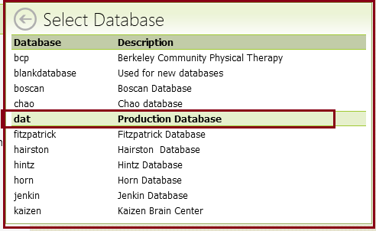
Step2:
Go To>Follow-Ups<Select Customer under Grouping and select Code under Drill Down<Select user AZ under Assignee and leave the system F/UP dates.
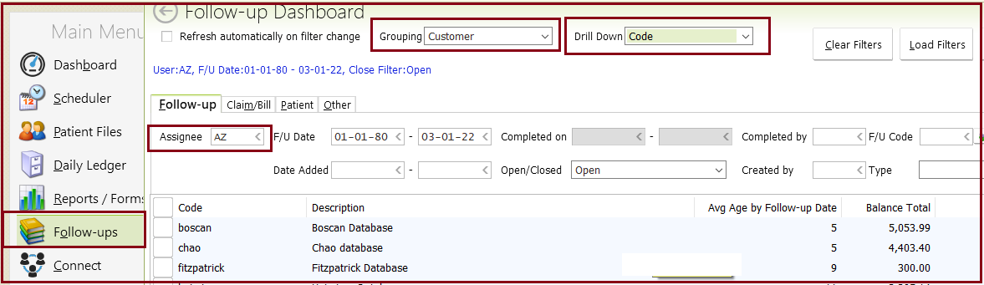
Step3:
Once selected dashboard follow-up options and will receive overall follow-up claims by dataset wise. So, review each claim notes and follow the same with rep as per Rev-Edition guidelines.
Rev-Edition Steps:

From the main menu, choose the “follow-ups” option. Make sure drop down menus for grouping and drill down are blank. For user, type AZ (For Oahu, replace AZ with KAM1 since that is your user in this database). All follow-up notes that are assigned to AllZone will be assigned to the user “AZ”. Then click the pink box with double blue arrows, button on the top right hand side of the screen. This will then show you all current follow-up notes that need to be worked.

1. When the reps are entering an eligibility note on an account they now need to click the button labeled "Complete and save". This will prevent this note from showing up as an un-worked follow up.

2. When entering in the follow up note stating "Updated facesheet and set claim to bill as per facesheet", Click the tab labeled "Complete and save". Also complete and save the prior MI notes on the account.

3. When working follow up and the rep has called an insurance company and is forced to leave a message, please have the rep assign the follow up to our database rep and add a follow up date 10 days from the date of the note. This will then assign it to APMB and give the insurance 10 days to respond before we follow up again due to no response.

4. When entering in an MI follow up note, please have the rep assign the follow up to the corresponding APMB user and add a follow up date 0 days from the date of the note.

5. When adding a follow up note please be sure to add a follow up date located at the top of the note. The date should coincide with the amount of time that is needed for a claim to process. Also you will need to assign it to the user that will need to follow-up on the note (ie: if it is something you would follow up on, assign the note to AZ. If it is APMB that needs to follow-up, assign it to the corresponding database user.) If a note no longer needs to be followed up on please click the "complete and save" tab to close the note.

Here are most of the possible codes that you may see in your follow up dashboard:

- A0 - This rejection states that the claim was forwarded to the responsible insurance. You will only be notified on these after 30 days have passed without a response. You will need to contact the payor and find out who they fwd the claim to.
*For Hairston, Jenkin, Kim, Dat Nguyen, T Nguyen, Ordonez and SDSNF - These will be given to you immediately to have you find out who the claims were forwarded to.
In either case, you will highlight the A0 rejection message and choose an action to perform. Actions are listed on the bottom of the screen.
These claims are valid follow up notes. These are from when the claim was forwarded to another payer for processing. They do not show up on your dashboard until 30 days have passed. At this point, you need to find out who the claim was forwarded to and what happened with the claim.
- A3- Acknowledgement/Returned as Unprocessable - This is usually related to an eligibility problem. The payor note will give you additional detail on what specifically is being rejected.

- A6/A7 - Acknowledgement/Returned for Missing Information - The payor note will give you additional detail on what specifically is being rejected.
- BDATA - Billing Exceptions - This code is used when a claim can not bill out due to some kind of missing or incomplete data. The note will give you additional detail on what specifically is missing/incomplete.

- BPINS - Billing - Insurance or Subscriber Except - This code is used when a claim can not bill out due to some kind of missing or incomplete data with the insurance or subscriber. The note will give you additional detail on what specifically is missing/incomplete.
- BREF - Billing - Referring Provider Exception - This code is used when a claim can not bill out due to some kind of missing or incomplete data with the referring physician. The note will give you additional detail on what specifically is missing/incomplete.
- BSUP2 - Billing - Provider Suppression - These are usually Missing Information accounts. Just check to see if insurance info has been received. Leave alone if none has been received. We will reach out to the provider.
- CONP - Contact Payor - These are claims that need to be called on. Additional details on why the need for the call are in the note.
- CSFIX - Fixed and Resubmitted clearinghouse/payor - These are claims that were rebilled. If it shows up on your follow-up dashboard, it will need to be followed up on to determine what happened with the rebilled claim.
- CUST - This is a custom note. Look at the detail of the note for direction on what needs to be done.
- DNIAL - Denial follow-ups will list reason and remark codes on them to give you more detail as to why it is denied. Use the “Remark/Reason Code” buttons to get the definition of the code.
- IPWP - In Process with Payor - If the due date is past due, we will need to call to get claim status.
- NOPAY - Payment Past Due - These are claims where we have not received a response from the insurance in the usual time frame that we would hear back from them. You will need to check claim status on these if no payment/denial is listed on the bill bar.
- NORSC - Clearinghouse Response Expected - This is waiting for the confirmation from Zirmed that they have received the claim. You will need to check these for an eob and/or a response from the insurance.
- NORSP - Payor Response Expected - These will only show on your board if we expected a response from the payor and did not receive one. You would need to check claim status if we have not received a response.
- REBIL - Rebill claim with Explanation - These will show up if a claim had been rebilled and is now past the due date for when the insurance should have responded.
- ROPEN - Claim has balance and is not closed - Usually this is due to a partial payment or a denial on the claim. Follow up as needed.
- UNDER - Claim was Underpaid - These happen when the insurance pays less than the expected amount.
- FOLLOW-UP RULES FOR UNDER CODE- This code claims were partially paid and some of the dates claims were denied. Please call insurance and get the status/clarification for unpaid dates claims.
- Follow-up Code Not Assigned - These are follow-up notes that were added without a follow-up note code defined. Please read the note and do the needful.

- WAITB- Moving forward 23rd of May’22, Please DO NOT work WAITB follow-up code claim and just ignore. Those will resolve themselves on the next batch billing in each database.
APPLICABLE ACTIONS COULD BE:

- CONP - Contact payor - Use this if you need to call the insurance. Put your notes in the reason section. Assign it to the needed user (whomever needs to follow-up on the note) and assign it a due date.
- REBIL - Rebilling claim with explanation - use this to refile the charges. First add a corrected claim note by selecting the service ticket for this date and then add it to the box 19 field under the supplier info section. The reason section of this action is where you will add your new note, that explains why you are rebilling. You will need to choose the corresponding form type for their insurance and make sure the original claim id is there if needed. If resending a claim with an original claim id, make sure the “7” box is checked as well. You will no longer set charges back to big A’s or B’s. You will use this action instead. It will create an additional bill bar with the “^” symbol. This indicates that it is a rebill. (Rebills will no longer show up as a yellow line. They get their own bill bars.) All notes will continue to be put on the original bill bar and will be automatically copied on the rebill bill bar by the system. Assign user and due date.
For Medicare claims:- Moving forward 18th of Mar’22, please DO NOT use original claim ID and resubmission code [7] and corrected claim notes when rebilling any claims for Medicare through Raintree. [Email<Roxanne<031822 Sub: Electronic Claims batches- Reg]
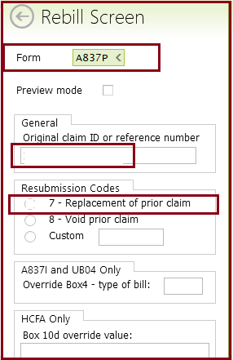

- REBILL FOR INSURNCE COVERAGE TERMED:
Just change the insurance from old to new as per termed steps, it will be adding big A to rebill.
- REBILL FOR NO CLAIM ON FILE CLAIMS:
Please rebill the claim through log follow-up Raintree, but don't choose 7 or the original claim number.
- CSFIX - Fixed and Resubmitted claim in clearinghouse - Use this action whenever a claim is corrected and rebilled in Zirmed. Assign user and due date.
- EXFIX - Claim Exception Fix - If a claim is held due to an exception, and the problem has been corrected, choose the action EXFIX. This prompts Raintree to recheck the claim for errors and then will send it to the insurance.
- NORSP - No Response From Payor - Use this action to track claims that are still in processing and need to be followed up on at a later date. Assign user and due date.
- PARWO - Partial Adjustment - Use this to make any needed contracted adjustments before the rest of the balance is adjusted off to something such as no auth or not medically necessary.
- WOFF - Adjusted - Using this adjustment option, adjusts off the entire balance left on the claim. It also closes the bill bar and any corresponding follow up notes that are on the bill bar.
- RESGN - Assign to New User with Explanation - Use this action to move a current follow up note to another user. Make sure to add a due date.
- TRANS - Transfer to next payor - Use this action to transfer the balance to the next insurance or to the patient. It will also close the bill bar and any associated follow up notes.
- If you receive a rejection for invalid info, please run eligibility and update the insurance as needed

TRANSFERRED TO THE PROPER PAYER- B11 CODE:
If claim denied as “The claim/service has been transferred to the proper payer/processor for processing”. Please call insurance and ask rep to find out who the claim forwarded to. This way we follow up with the proper payer. Also if we need to bill to another insurance in the future we can update the insurance and do so.
B11 Code claims- For Jessie's clients (Jenkin, Dat Nguyen, T Nguyen, Ordonez, RAMC, and SDSNF), he would like you to call to find out who the claim was forwarded to. We need this information in case it should be going direct to them.
For the other databases that have B11 tasks-You are only assigned these tasks after 30 days have passed since the claim was forwarded. We need you to contact the payors to determine where the claim was forwarded to and what the status is.
NO BALANCE ON CLAIM:
If claim was already adjusted for CO-29 and CO-164 denials by ERA posting without closing bill bar, please hit enter on the bill bar and type "P" for claim paid. This will close the bill bar and mark all notes on it complete.
FOLLOW-UP NOTES:
- As per the guidelines for the new rev edition version of raintree please have the reps add either a follow up date to notes or complete and save them when adding the notes.
- If the note is informational only the note can be completed and saved.
- If the note needs to be followed up on then add the date it needs to be followed up on and the user who needs to do said follow up.
- Also be sure that all notes added for allzone to follow up on in the future are listed under user "AZ" without the number behind it. This is how we are now tracking these.
SECONDARY CLAIMS:-
For 23/45 reason code, if Medicare was processed deductible only and secondary [Medi-Cal or Medi-Cal HMOs] was not paid that amount, please verify eligibility and update notes in bill bar and set it to a Big B. APMB will take care to submit the claim.
CO-236 DENIALS:-
If claim denied as “This denial is received when the service(s) has/have already been paid as part of another service billed for the same date of service”. Please add 25 modifier for E/M and re-bill the claim with “Corrected claim” through Raintree.
- 99223-25
- 99497/99498
CO-119 DENIALS [MEDI-CAL]:-
If claim denied as “Benefit maximum for this time period or occurrence has been reached” for Medi-Cal patient, please review in ledger and adjust the remaining balance in RT.
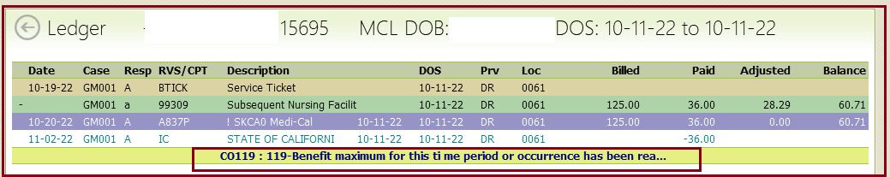
CO-29 TFL CLAIMS:-
Please see below CO-29 denial claims process,
For Dat Nguyen database, they will auto write off the balance and you will not receive an open follow up note on these.
For the other databases, this denial code will not auto write off the balance and you will receive a follow up note on them. We need to have you check these to see if they were filed in a timely manner. If you find that they were not filed within the payors filing limits, you may write off these charges to the filing limit adjustment and close the open follow up note. If they were filed timely, please appeal the denial with proof of timely filing.
MEDI-CAL & MEDI-CAL HMOs:-
If deductible was not paid for secondary insurance by ERA, please adjust the deductible amount.-See example denied code as OA23/CO45.
PI 243 DENIAL CODE:-
If received claim denied with PI 243 code in Sanders dataset, please move them to user Sumer in Raintree in the follow ups. She is the Office Manager for Dr. Sanders and needs to work through those.
MEDI-CAL CLAIMS REASONS CODES N781 & N782:-
If we are seeing remark code as N781, N782 on Medicare cross over claims. Please review in ledger as Medi-Cal were not processed the payment.
If yes, please adjust the Medi-Cal balance whenever seeing remarks code as “N781 and N782” since according to the Medi-Cal site for rates, they only allow $24.00 for the 99213 so they would not pay more than Medicare does, ok to adjust the balance.
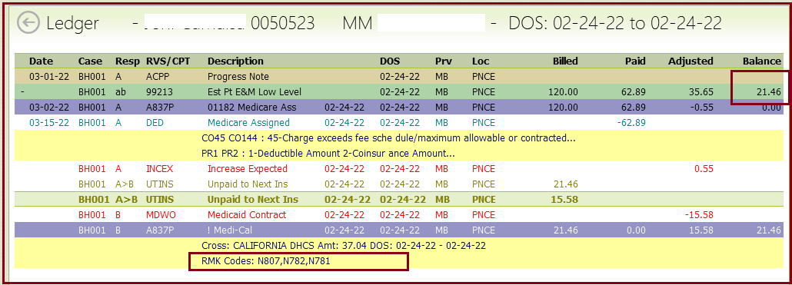
Dashboard (RAMC) - NORSC & NORSP:
The NORSC codes are receiving in Dashboard follow-up for after four days (Submission date). However, it is not required to follow up within 30 days for electronic claims, with the exception of rejections.
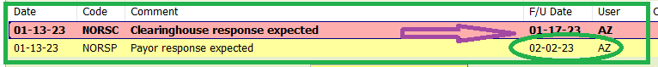
APMB (Kristen) had corrected the programming so that we will not receive these in the future (Northern CA Medicare).
Dashboard – A1 & A2
Allzone Clarification: A1 and A2 are just acknowledgment purposes and indicate that the clearing house has passed all edits and has been accepted for processing. Therefore, we closed these A1 and A2 codes on the dashboard follow-up and will follow-up the other code (NORSP) created for the same claim
APMB (Kristen) Response: Programming has been fixed so that you will not see these in the future. I have closed any open follow up notes for this code.
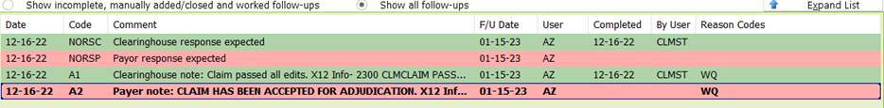
FOLLOW-UP NOTES:
Effective from 20th of Jan’23 onwards, please use the below Follow-up code when updating the notes into RT Software under [Log Follow-up Claim Follow-up].
