KAISER – CLAIM STATUS CHECKING HINTS

Usually, rep refused to provide claim status over the phone advice to get the status through guest portal,

Rep given the hint on how to key the member id# on the guest portal. Please see below and make a use of it.

https://healthy.kaiserpermanente.org/northern-california/community-providers

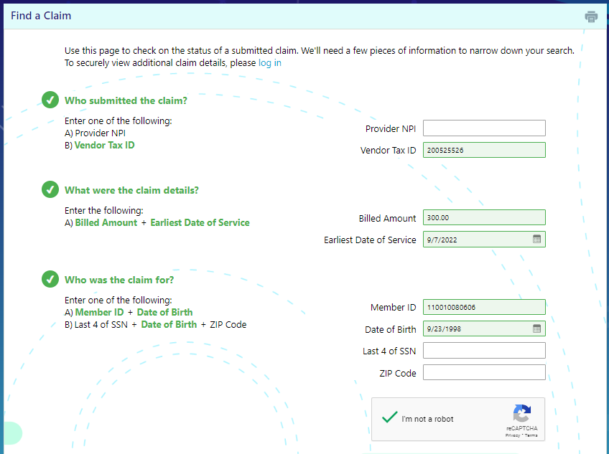

1, Rep told that we have to use either NPI or ax id#, no need to put both NPI and tax id#.

2, we need to enter the billed amount and the Beginning DOS.

3, When entering member id#, the below needs to be followed
A, generally the medical record# would be 8 digit while entering member id# on the gust portal we need to use 12 digit.
B, if the patient belongs to Northern region we need to add: 1100 at the beginning of the member id#, Example: Medical records# 10080606, we need to add 1100, and key the member id# as 110010080606 If the medical records is 7 digit we need to add additional 0 after 1100. We need to key 110001008060
C, if the patient belongs to Southern region we need to add: 0000 at the beginning of the member id#, Example: Medical records# 10080606, we need to add 0000, and key the member id# as 000010080606 If the medical records is 7 digit we need to add additional 0 after0000. We need to key 000001008060.

Please see the claim status I got from the gust portal:

