CARC CODE CO151 - Payment Adjusted Because the Payer Deems the Information Submitted Does Not Support This Level of Service
Description - This denial occurs when the documentation provided does not justify the level of service billed.
Next Steps:
Handling Denials for this CARC Code:
Before continuing to workflow Please ensure we are using all available resources to determine the appropriate authorization information. Consider the following scenarios when a claim is denied for lack of authorization:
- Use all available resources (Client system, Payer Portals, Payer Policies, Client SOP’s, Standing Rules, PhyTech Workflows, etc…)
  - Standing Rule Note: (Check Standing Rules and SOP’s - Do NOT add to NEEDBACK if client already has a standing rule to adjust off and/or adjust to CASH) – Apply the standing rule to your claim.

Action Needed when CPT is 87641 -
- Change the units of 87641 to 1 unit
- When rebilling a corrected claim please ensure that:
  - You are rebilling ALL service lines on each claim (not just the corrected portion, you must rebill the entire claim)
  - If the claim is not traditional medicare, please include the prior claim number and select (see below)
    - All non-traditional Medicare
      - Submission Code 7
      - Enter Claim number
      - Rebill all lines
      - Note the account
    - All Medicare
      - Submission Code 1
      - Rebill all lines
      - Note the account
- 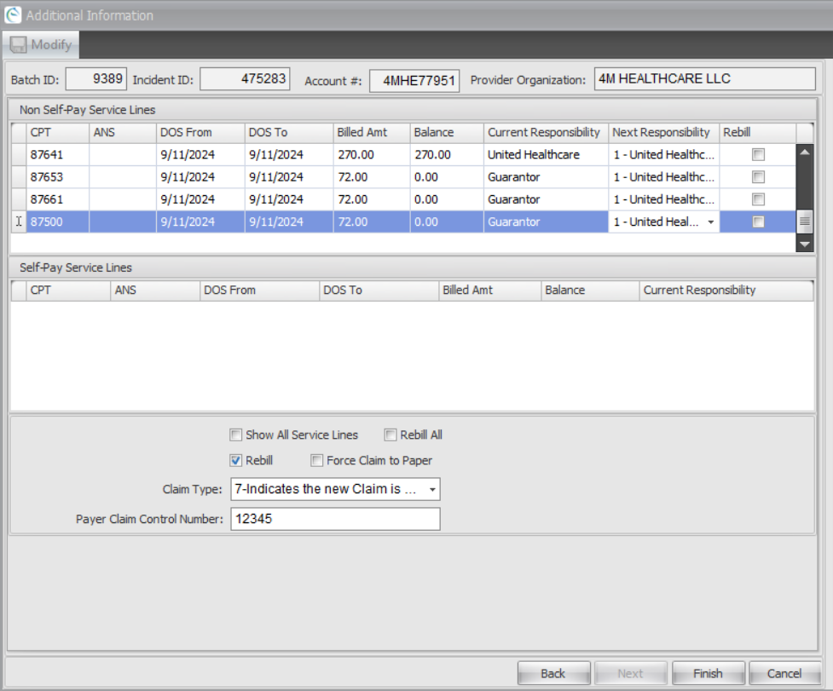
- Save & Move Claims to Aging for 22 days

Action Needed for all others -
- Determine what was submitted to the payer and review the information submitted
  - Did we send all records requested?
    - Yes – Call the payer to learn more about the detail they are needing and/or gather more information regarding the denial
    - No – Submit complete records
  - Report Issue to Management Team for review

Next Steps:
Please review, research, and resolve these claims to ensure we obtain the appropriate payments.

