CO24 - Charges are covered under a capitation agreement/managed care pl

Next Steps:
Handling Denials for this CARC Code:
Before continuing to workflow Please ensure we are using all available resources to determine the appropriate authorization information. Consider the following scenarios when a claim is denied for lack of authorization:
- Use all available resources (Client system, Payer Portals, Payer Policies, Client SOP’s, Standing Rules, PhyTech Workflows, etc…)
  - Standing Rule Note: (Check Standing Rules and SOP’s - Do NOT add to NEEDBACK if client already has a standing rule to adjust off and/or adjust to CASH) – Apply the standing rule to your claim.

May be covered by another MCO plan
Provider may receive capitated payments

Next Steps:
May be covered by another MCO plan: Wrong Insurance/Other Insurance/Other MCO plan
*Action: Use available resources to determine the correct insurance based on eligibility and the client system.
- Check PHI Eligibility
- Check Client System
- Verify Provider Portals
  - If correct insurance is found:
    - Update Insurance in PHI for all applicable DOS/Claim(s)
    - Check Eligibility
    - Rebill Claim to correct primary insurance.
      - Problem Type: REBILL
      - NA Date: 22 days from the rebill date
      - Reassign to: ZZ-Needback work queue
  - If correct insurance is NOT found:
    - Add the claim to the client needback list.
    - Problem Type: NEEDBACK
    - NA Date: 5 days
    - Reassign to: ZZ-Needback work queue

Provider may receive capitation payments
*If you find the denial is not for other insurance but that this provider receives capitation payments, please use all available portal resources to pull remits – if available.
If not available – please reach out to your manager.
General Expectation
All team members must exhaust all internal efforts to resolve claims and secure payment before requesting additional information from the client.

Using a KPC account as an example;
Here are steps to checking Medi-Cal elig in Availity RCM. This will tell you what IPA/MCO to send the claim to. This will need to be checked for all claims that come over with Medi-Cal and any claim that rejects in RCM for a California Medicaid plan.

Example: If we received Inland Empire and it rejects check RCM elig first to see if we are sending to the correct payer. If no IPA/MCO is listed and Medi-Cal is active, then the claim needs to go to Medi-Cal. IF elig reflects the pt has no active coverage for Medi-Cal then you would perform the next action that is specific to the client. (e.g. add to NB or bill pt).

Log into RCM select KPC at the top


Registration/eligibility & Benefits
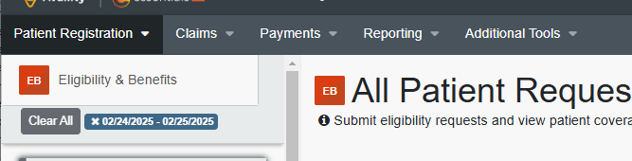

Click on Review & Submit Requests
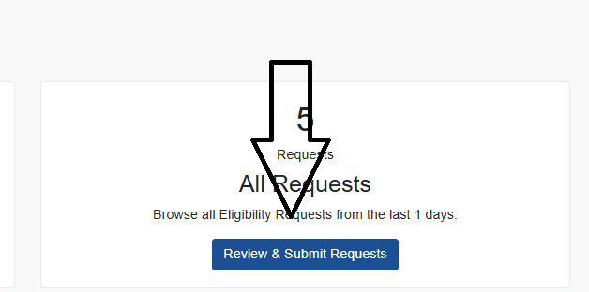

Then New Request
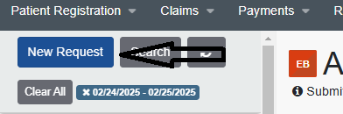

Select payer, Provider, then add the Provider PIN, the one here is what needs to be added
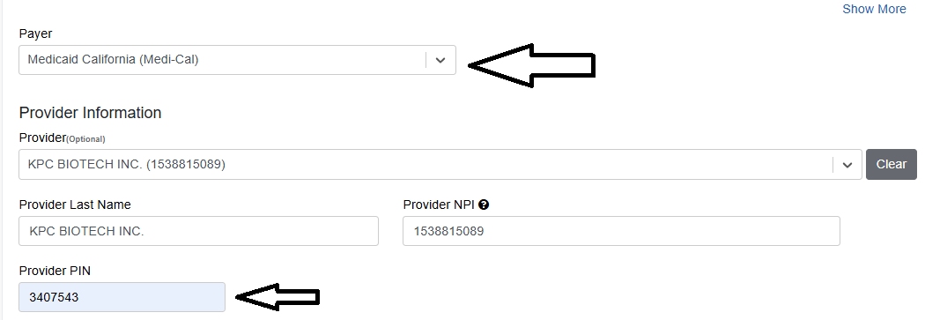

Then pt ID and dob then submit
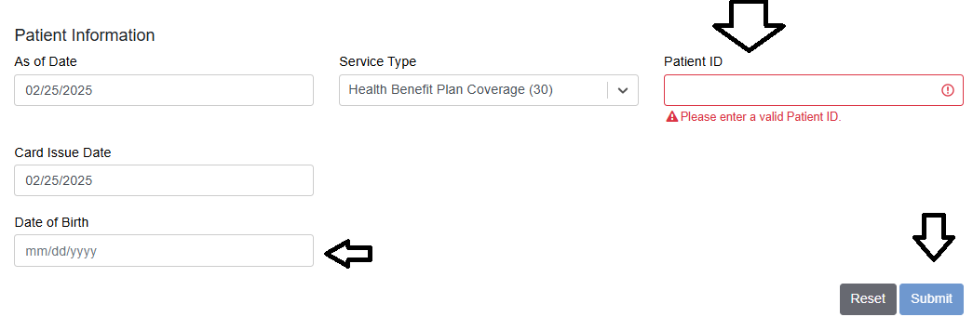

It will then say “processing” click on that box and it will show pt elig
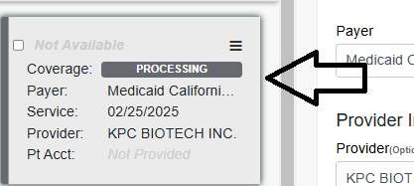

Click coverages and benefits
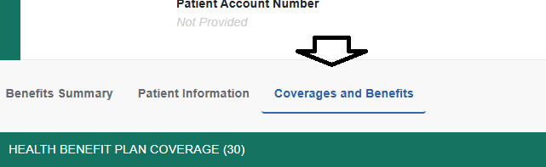

IF they have an IPA/MCO it will show here
