Canned Notes
Canned Notes:
Canned Notes are designed to help our team save time by providing a default template for documenting claim statuses or issues. These notes are primarily intended for use when calling payers to check the status of a claim.
If you are only reviewing correspondence or the Explanation of Benefits (EOB), you do not need to use the full canned note. Similarly, when checking claim status via a provider portal, not all fields in the template may be applicable. In such cases, feel free to use the canned note as a base and remove any sections that don’t apply due to unavailable information.

However, you must call the payer if the claim is denied and additional details are required—such as policy information or denial reasons for an appeal or reprocess request.

Alias | Description
2nd Bill | Secondary Claim Billed
2nd FU | Status of secondary claim
2ndCREDI | Credit after secondary paid
ADJUST | Account Balance has been Identified
ClBILL | Client Bill, no action taken
Client | Client Review for Next Steps
CLMPAID | PAID CLAIM STATUS VIA PROVIDER PORT
CLMPROCE | IN PROCESS CLAIM STATUS VIA PROVIDE
DENIED | CLAIM DENIED
MEDRECS | CLAIM PENDED MEDICAL RECORDS
NCOF | No Claim on File
PATIENT | Remaining responsibility is Patient
REBILL | CLAIM REBILLED OR CORRECTED CLAIM S
REJECTIO | CLAIM EDIT ERROR MANAGEMENT REJECTI

To Utilize CANNED NOTES in PHI – please see the following;
When working your queue – there is a CANNED NOTE tab/button above the note BOX here –
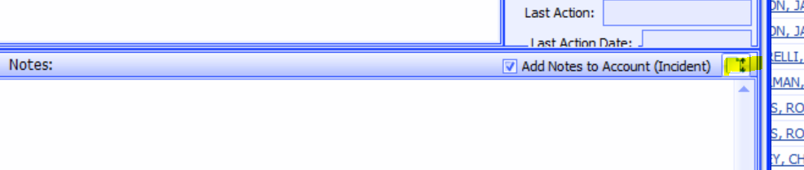

Selecting this tab/button will generate a pop up box that looks like this
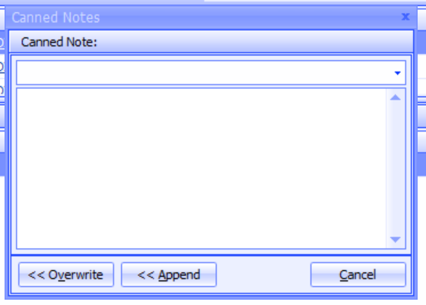

Here you will use the drop down to select your CANNED NOTE as applicable to the claim status

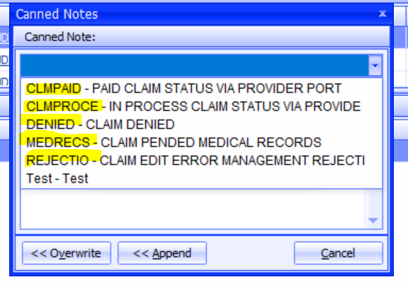
Then hit APPEND
This will add your CANNED NOTE to the NOTE BOX
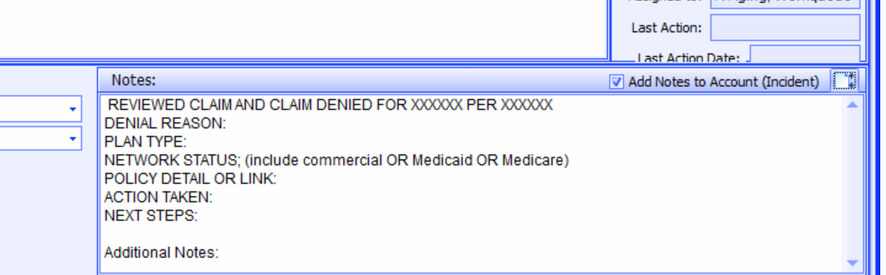
Categories and its Format:
CATEGORY | FORMAT
CLMPAID - PAID CLAIM STATUS VIA PROVIDER PORT | REVIEWED CLAIM STATUS ON XXXXXX, CLAIM # XXXXXX RECEIVED ON XXXXXXX  CLAIM PROCESSED ON XXXXXX AND PAID IN THE AMOUNT OF $ XXXXXX  PATIENT RESPONSIBILITY $ XXXXXX. CHECK NUMBER XXXXXX. PAID DATE XXXXXX  SAVED EOB TO PHI DOCUMENTS/DROPPED TO BOX - REASSIGNED TO THE A-PEND PAY WORK QUEUE FOR PAYMENT POSTING TO PROCESS.
CLMPROCE - IN PROCESS CLAIM STATUS VIA PROVIDE | REVIEWED CLAIM STATUS ON XXXXXX, CLAIM # XXXXXX RECEIVED ON XXXXXX  CLAIM STILL IN PROCESS, PLEASE ALLOW MORE TIME, WILL FOLLOW UP.
DENIED - CLAIM DENIED | REVIEWED CLAIM AND CLAIM DENIED FOR XXXXXX PER XXXXXX  DENIAL REASON:  PLAN TYPE:  NETWORK STATUS; (include commercial OR Medicaid OR Medicare)  POLICY DETAIL OR LINK:  ACTION TAKEN:  NEXT STEPS:  Additional Notes:
MEDRECS - CLAIM PENDED MEDICAL RECORDS | CLAIM # XXXXX RECEIVED ON XXXXXX AND PENDED MEDICAL RECORDS  PRINTED MEDICAL RECORDS AND SAVED TO ACCOUNT DOCUMENT MANAGER  SUBMITTED MEDICAL RECORDS VIA THE - XXXXXX. PLEASE ALLOW XXXXXX DAYS WILL FOLLOW UP
REBILL - CLAIM REBILLED OR CORRECT CLAIM | REVIEWED CLAIM STATUS ON XXXXXX, CLAIM # XXXXXX RECEIVED ON XXXXXX  CLAIM DID NOT PROCESS DUE TO XXXXXX  CORRECTION MADE XXXXXXX  REBILLED CLAIM. NEXT ACTION: PLEASE FOLLOW UP ON CLAIM THAT WAS REBILLED.
REJECTIO - CLAIM EDIT ERROR MANAGEMENT REJECTION | REVIEWED CLAIM STATUS ON XXXXXX, CLAIM REJECTED ON XXXXXX  STATUS CLAIM REJECTION XXXXXX REASSIGNED/SENT TO BILLER FOR REVIEW
2nd Bill - Secondary Claim Billed | Reviewed account. All CPT codes paid by primary. Reviewed EOB from primary to ensure not crossed over. Billed claim to secondary payer - will follow up.
2nd FU - Status of secondary Claim | Primary Insurance paid in full all CPT code/lines billed. Status 2ndary claim.  Per XXXXXXXX (portal or call) Status of claim is XXXXXX
NCOF - No Claim on File | Followed up on claim and per XXXXXX no claim on file. Checked Availity RCM for claim status. Claim status was XXXXXX in Availity RCM.  Per workflow found claim only billed X1 time - rebilled claim  ** if claim was billed and rebilled - follow workflow
PATIENT - Remaining responsibility is Patient | Reviewed EOB and balance of account. Determined remaining balance is patient responsibility. Updated Responsibility of claim to GUARANTOR

