DOCUMENT MANAGER IN PHI

Back in December 2024, I submitted a ticket to PHI regarding an issue we identified: documents saved in the follow-up Workqueue are not being saved to the account. It appears that there has not been resolution to this and as a result, once a claim is closed, those documents become inaccessible.

To address this, we need to make a small but important adjustment to our workflow to ensure we retain access to all relevant documents.

Effective immediately – 1st of July’25
When we receive any file (EOBs, correspondence, faxes, requests) or when we send any documents to payers (appeals, medical records, W-9 requests, etc.), we must save them to the Document Manager in the account — not in the follow-up Workqueue.

NOTE: **this does NOT apply to payment posting – only to our follow up process under the INSURANCE FOLLOW UP. Payment posting will continue to save to document manager so the EOB links to the paid line item. ERA’s will automatically save.

Please ensure this becomes part of your regular process going forward. Let me know if you have any questions.

@Management – please share with your team members as you see fit.

To access Document Manger in the account;

When in the follow-up workqueue-navigate to the left side and click on the hyperlink to the account.
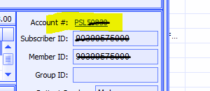
Once in the account – navigate to FILE > Document Manager

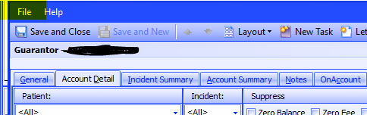

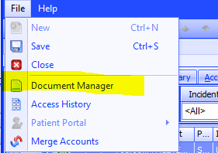

Hit the GREEN Plus Button
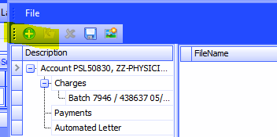

Choose your saved document from File Explorer
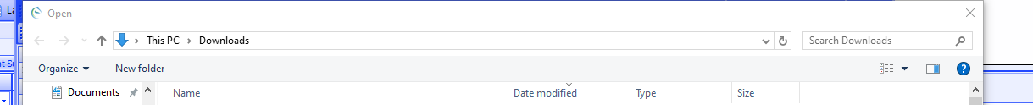

Click OPEN
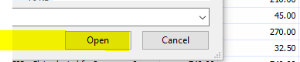
Chose the document type from the “Document Type” dropdown
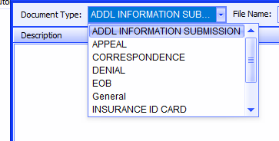
Relabel the document to the DOS for easiest reference
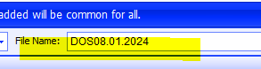

Add any additional notes on the detail of the document to “Description’ and hit OK
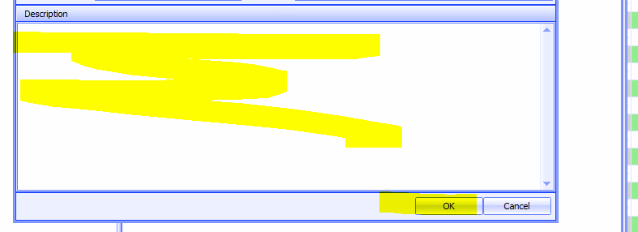

Lastly, Hit SAVE and the document will turn RED once its properly saved to the account
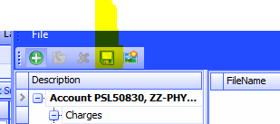

Once saved you can exit back to your insurance follow up task to complete your account action(s).

Email<30th of July’25 Sub: Document Manager in PHI

