MEDICARE PRIMARY CROSSOVER CLAIMS WITH SECONDARY INSURANCE

While our BPO team does not work Medicare claims – we still need to review claims assigned to Medicare as the payer, when the balance billed and the current balance does not match. This indicates that Medicare has paid and possibly crossed over the claim.
When the primary insurance is Medicare, PHI does not flip the claim to secondary automatically. Why? Because we have Medicare shut off in PHI to not send a secondary claim… REASON? Because Medicare crosses these over automatically and when medicare was sending the claim AND PHI was sending the claim, it causes mass duplicate secondary claims on file…..
Because of this….. everything that Medicare has paid, that is now secondary responsibility is stil under “Medicare” PHI doesn’t automatically flip it to secondary responsibility.
If Medicare issued payment, open the EOB/ERA file to ensure that Medicare crossed the claim over.
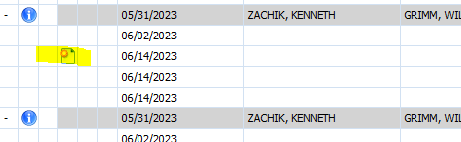
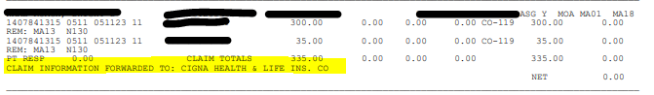
When these come up in your queue to work, we need to automatically flip the responsibility in PHI to secondary **DO NOT BILL THEM TO SECONDARY **

You can do this from the ledger here
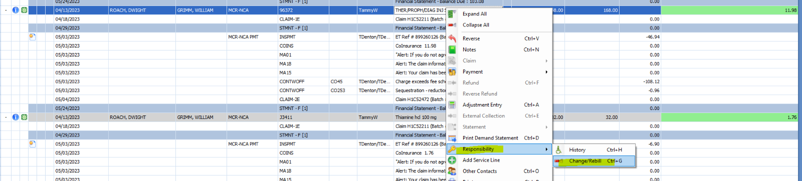

Change all lines to secondary responsibility for those that medicare paid
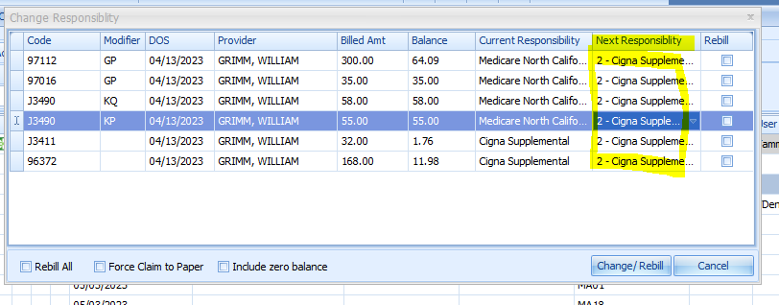
Then hit Change/Rebill **** do NOT check the rebill boxes and do NOT rebill the claim **
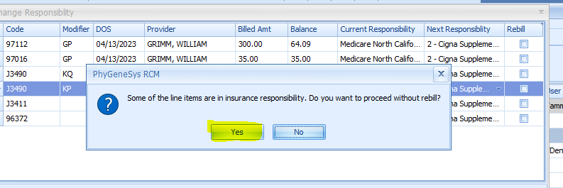Now your claim in your workqueue will be under secondary

Once Medicare has processed all line items and you have flipped the account to secondary insurance (if crossover) then reassign to AGING for follow up to the secondary insurance.

