11/19/2025

MOLINA HEALTHCARE MS
Po Box 22618
Long Beach, CA, 90801

Patient Name James P, Smith Jr.
Member Name James P Smith Jr.
Policy Number 852727470
Date of Service 08/19/2025
Claim Number 25254227019
Billed Charges $323.00
Account Number redm10723

To Whom It May Concern,
I am writing to formally appeal the denial of payment for services billed under HCPCS code G0483 for our mutual patient, a member of Blue Cross Blue Shield of Kansas City (BCBS KC). We request that the claim be re-evaluated and processed in accordance with BCBS KC's specific policies, particularly concerning the appropriate coding for definitive drug testing services.
Background:
- Patient Information: [Patient's Name], BCBS KC Member ID: [Member ID]
- Date of Service: [Date]
- Billed Code: G0483 – Drug test, definitive, 22 or more drug classes
- Requested Code Adjustment: G0480 – Drug test, definitive, 1-7 drug classes
Below are excerpts from this policy which support our reasoning.
Upon reviewing BCBS KC's medical and payment policies, we recognize that the coding for definitive drug testing should accurately reflect the number of drug classes tested. According to the Centers for Medicare & Medicaid Services (CMS) guidelines, definitive drug testing codes (G0480-G0483) are differentiated based on the number of drug classes tested, with G0480 representing 1-7 drug classes and G0483 representing 22 or more drug classes.
Centers for Medicare & Medicaid Services
In this case, the services provided involved testing fewer than 22 drug classes. Therefore, billing under G0483 may not align with BCBS KC's coding policies. We propose that the claim be adjusted to reflect HCPCS code G0480, which accurately represents the services rendered.

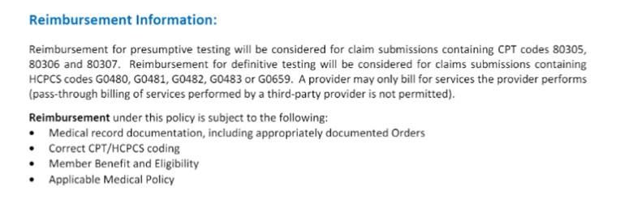
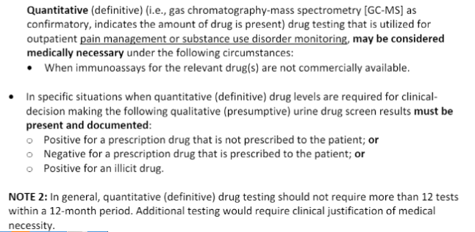

We respectfully request that BCBS KC reprocess the claim under HCPCS code G0480, ensuring compliance with both BCBS KC's policies and CMS guidelines. This adjustment will accurately represent the services provided and facilitate appropriate reimbursement.
Thank you for your attention to this matter. Please let us know if additional information or documentation is required to facilitate this adjustment.

Sincerely

Your Name
Reimbursement Coordinator
(833)749-8324, extension
collections@phytechsolutions.com

Enclosures: Claim Copy
Medical Records

