11/19/2025

MOLINA HEALTHCARE MS
Po Box 22618
Long Beach, CA, 90801

Patient Name James P, Smith Jr.
Member Name James P Smith Jr.
Policy Number 852727470
Date of Service 08/19/2025
Claim Number 25254227019
Billed Charges 323.00
Account Number redm10723

To Whom It May Concern,
We are submitting an appeal regarding the above-referenced claim, which was denied in error for “Procedure code billed is not correct/valid for the service billed”, as indicated in the adverse benefit determination on the Explanation of Payment we received. We respectfully request a reconsideration of the claim, specifically for CPT codes 87481, based on the attached medical records and policy outlined below.
According to your policy, these services are considered payable benefits. The provided medical records clearly demonstrate the necessity of the procedure(s) performed on your member. We kindly request that these records be reviewed by a medical professional with equivalent education and training to the provider who both directed and performed the procedure, ensuring an accurate assessment of the coverage of services rendered.
CPT code 87481 on claim 25254227019 denied stating “Procedure code billed is not correct/valid for the services billed.” We contacted the claims customer service and were advised that “the CPT code is not covered.” Per Caresource Ohio -Genetic Testing – Polymerase Chain Reaction (PCR) Testing PY-0101 policy section III; J; K and L.
This paragraph is specific to “quantification” test. The test we performed is a “qualitative” test. The test is to determine what bacteria is causing your members UTI (see attached test requisition and results)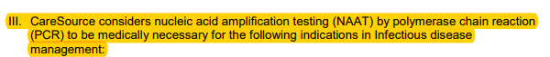
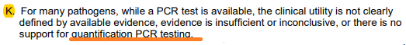
We are requesting reconsideration for payment for this CPT code on this claim as there are no provisions in this policy that states the CPT code 87481 is not covered for a “qualitative” test with the indications listed on the requisition.
XXXXX (claim number in this paragraph/sentence line - this is for Hometown claim example, if using this letter for another client, please update this sentence/lineXXXXXX Please reference claim #2435202CPY00 with same 87481 cpt code processed and paid.
Following your thorough review, we ask that you overturn the denial and reprocess the claim for payment at the highest level of network benefits available. Should any additional documentation be required for a complete review, please provide a detailed outline of the records that were reviewed and specify any further information needed to approve the procedure(s) performed.
We appreciate your prompt attention to this matter and look forward to your response.

Sincerely

Your Name
Reimbursement Coordinator
(833)749-8324, extension
collections@phytechsolutions.com

Enclosures: Claim Copy
Medical Records

